## Installation Guide

Firstly, download Apache solr v7.5.0 binary release and unzip it. Then through the command prompt, navigate inside solr-7.5.0/bin folder as shown in the picture below by using your own path to that folder. After that, write the command ‘solr start’ and Apache solr should start on port 8983.

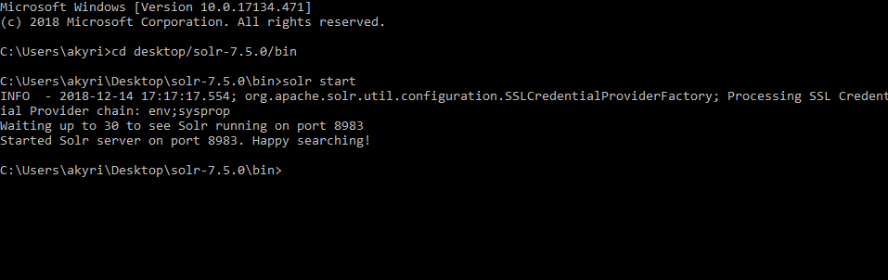

Figure 1. Starting apache solr from cmd.

Then, create four folders named edam, swo, biotools and hybrid under solr-7.5.0/server/solr directory. You will need to copy and paste all the files and folders that exist under solr-7.5.0\server\solr\configsets\_default\conf directory to all four folders created previously as shown to the example figure below. Do that for edam, swo, biotools and hybrid folders.

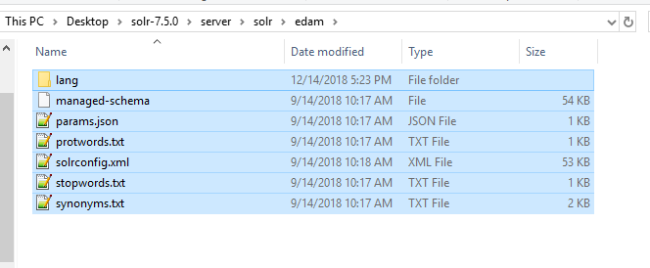

Figure 2. Example of the EDAM folder.

After completing that step, navigate to localhost:8983 through a browser. You will need to create four new cores with the names and instanceDirs edam, swo, biotools and hybrid respectively as shown in the example figure below.

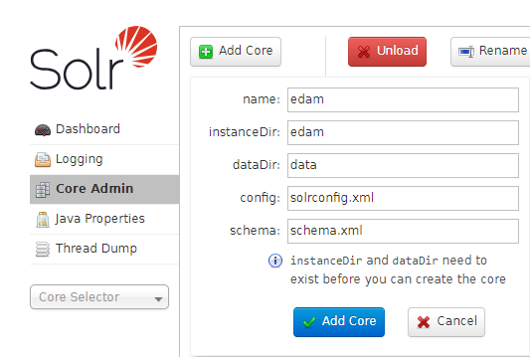

Figure 3. Example of creating EDAM core in apache solr.

For all three cores, you will need to upload the given json files, EDAMSolr.json, swoSolr.json, biotoolsSolr.json and hybridSolr.json for each core respectively as shown in the example figure.

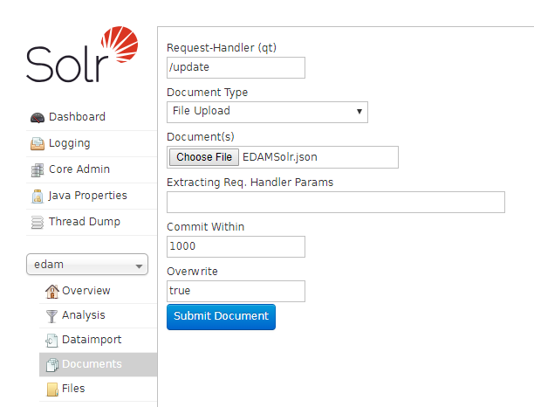

Figure 4. figure of uploading the edam json file in apache solr's EDAM core.

The last step to finish with Apache solr configuration, is to open solrconfig.xml file for all four cores that is located under solr-7.5.0\server\solr\edam, solr-7.5.0\server\solr\swo, solr-7.5.0\server\solr\biotools and solr-7.5.0\server\solr\hybrid respectively. You will need to add the line ‘<str name="fl">*,score</str>’ in the /select requestHandler as shown in the figure below.

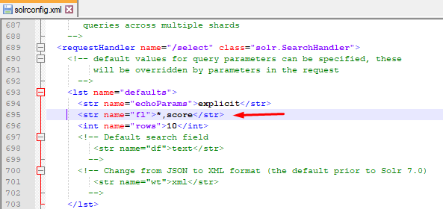

Figure 5. Apache solr cores' configuration.

After completing those steps, Apache solr is set and ready. The next step is to download and install pgAdmin software. After installing it, create a new database named ontosearch and run the sql script given in the file OntoSearchDB.sql. After running that script, you should have two tables created in the ontosearch database with the names solrresultsedam and solrresultsswo like shown in the figure below.

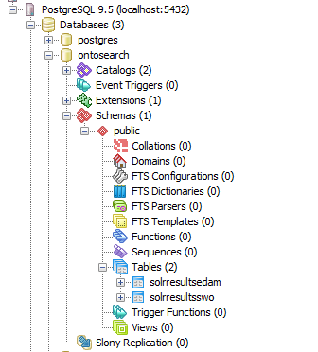

Figure 6. PGadmin3 ontosearch database.

After the database is set, download and install XAMPP Control Panel. Download MySQL service through XAMPP, if you haven’t downloaded it already during installation, and start it as shown in the figure.

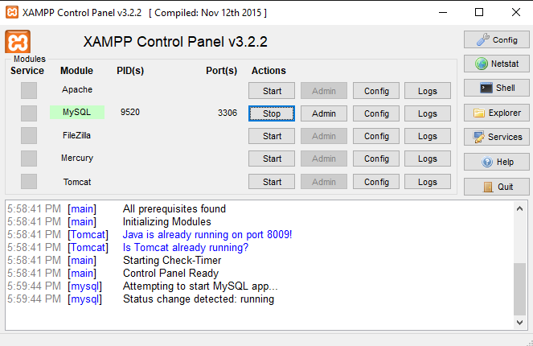

Figure 7. XAMPP Control Panel.

Next step, is to download and install NetBeans IDE v8.2 and open the given NetBeans project ‘OntoSearch.zip’. In the DBController class, you will need to change the username and password to your own database username and password as shown in the figure below.

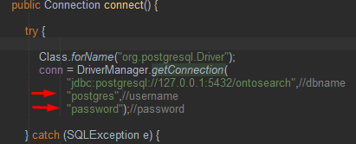

Figure 8. OntoSearch DBController class.

The last step, is to build and run the project under Tomcat server in NetBeans. The web application should start under <http://localhost:8084/OntoSearch/> .